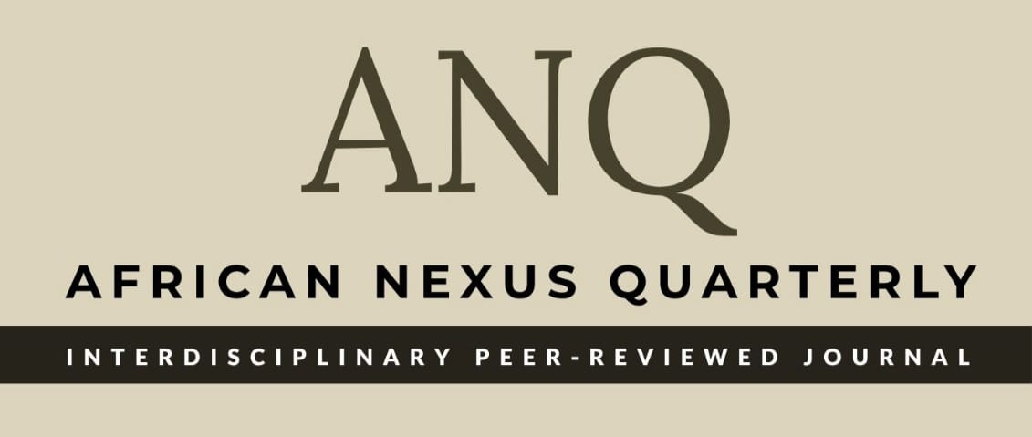

African Nexus Quarterly

Responses to the Reviewers' Comments Form
Manuscript Title: Transforming Marginalisation Through Community-Based Education: Effects of an Integrated Adult Literacy and Civic Education Program on the Batwa Indigenous People in South-West Uganda
Corresponding Author: __________________________________________________
Reviewer & Comment No. | Reviewer's Specific Comment / Recommendation | Author's Response & Actions Taken | Page / Paragraph No. in Revised Version
Reviewer 1 - Comment 1
Reviewer 1 - Comment 2
Reviewer 2 - Comment 1
Editorial / Stylistic

